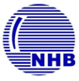 TPM Club of India Magazine:
About NHB Plant:
Established in 1969, NHB is one of the leading manufacturers of Chrome, Stainless, Brass & Aluminum balls in India and regular supplier to prominent companies all over the globe: USA, Canada, Europe and the Asia - Pacific region. The company has a strong focus to achieve leadership through Quality, innovative and sustainable products.
Supplying to Multinational Bearing, Automotive & Cosmetic industry in 20 Countries.
Expectation from TPM:
- To achieve and sustain Zero Accident, Zero Breakdown & Zero Defects in all areas
- High Productivity
- Reduce the losses by 30%
- Increase in Employee Ownership
- Involvement of Employees in continual Improvements
- Upgrade over all skill level and empowerment of employees & Multiskilling of them
- Improve 5S to make visible shop floor
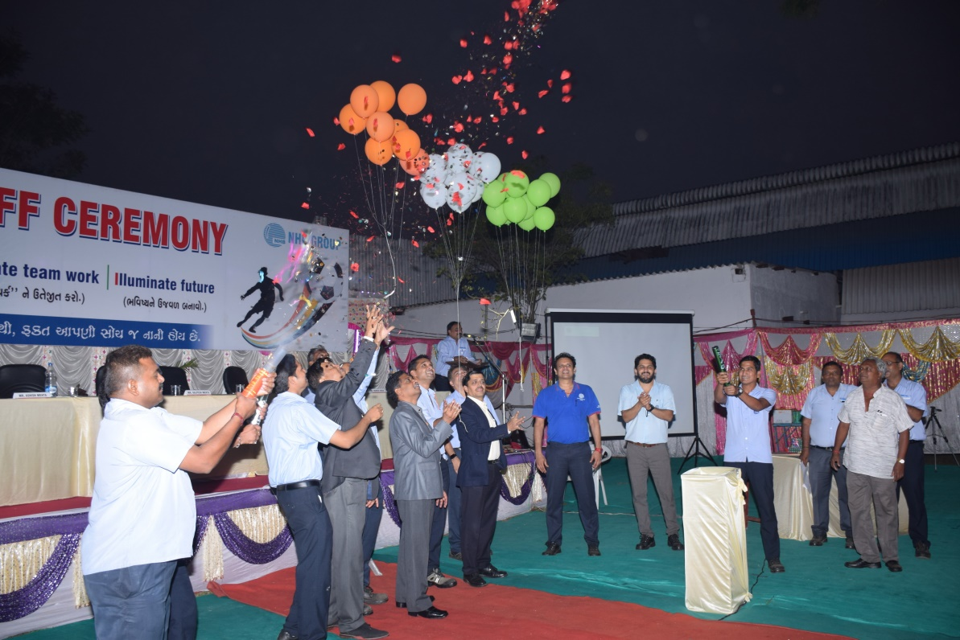
NHB Plant TPM Kick Off –Dec’17

Results achieved from Manager Model Machines (MMM) : Jan’17 to Dec’17
Production Improved by 15%, Breakdown reduced by 10%, 1257 of Kaizens Implemented, Zero Accidents, Training Man-hours increased, Customer complaint & In-house rejections reduced drastically.
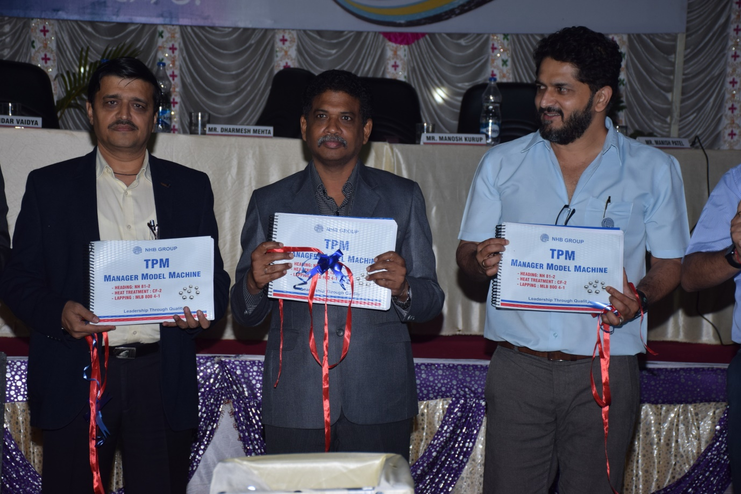

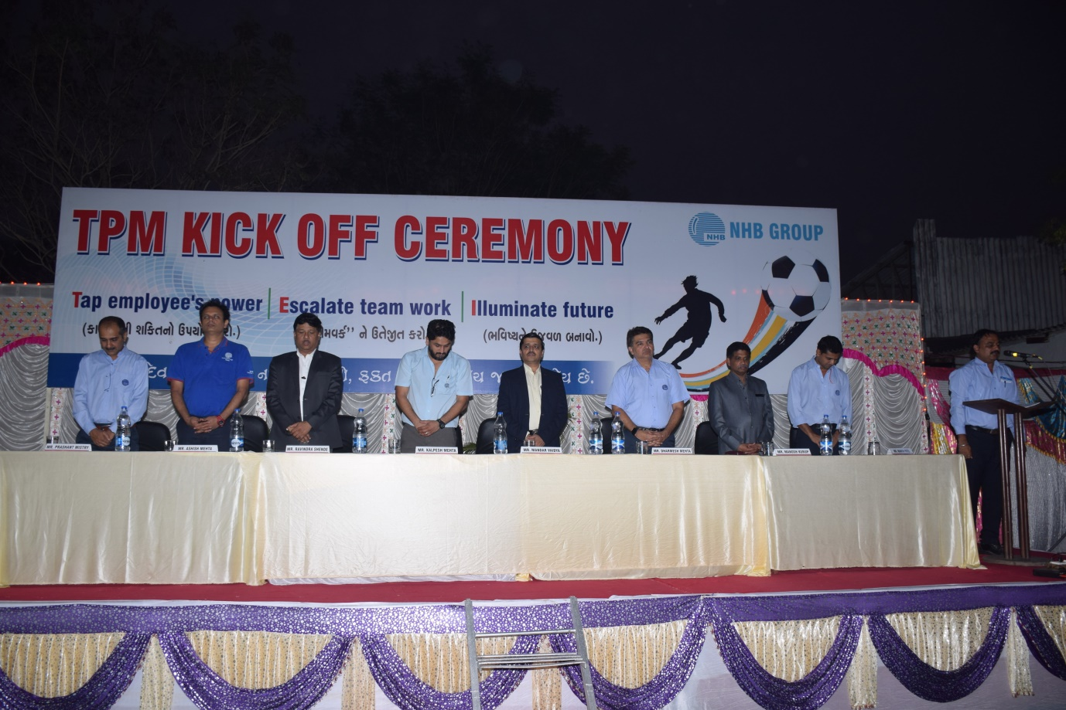
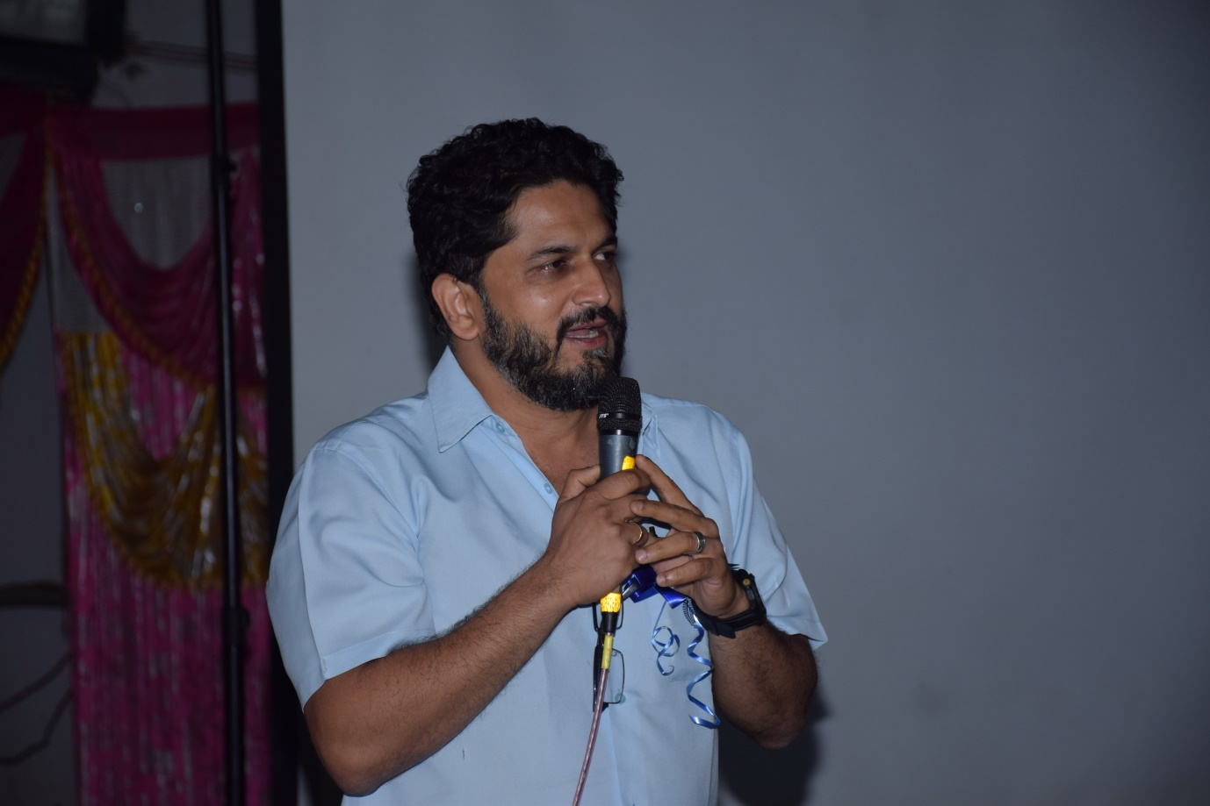
Managing Director (NHB) : Kalpesh Mehta

